Lab#10

**Objective**: To implement preserving user state in distributed applications.

**Task:** Create a simple login logout and profile page and use cookie to preserve user state .

**Login Page:**

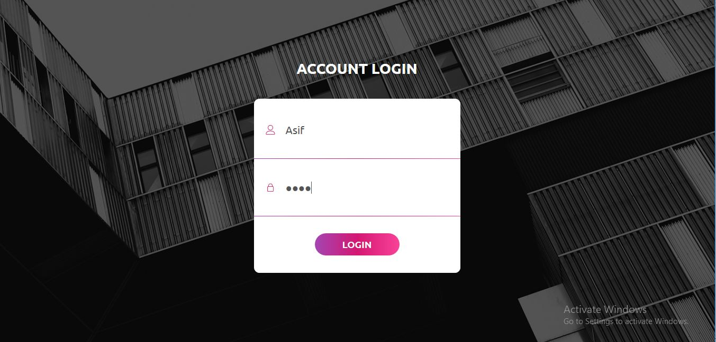

**Profile Page:**

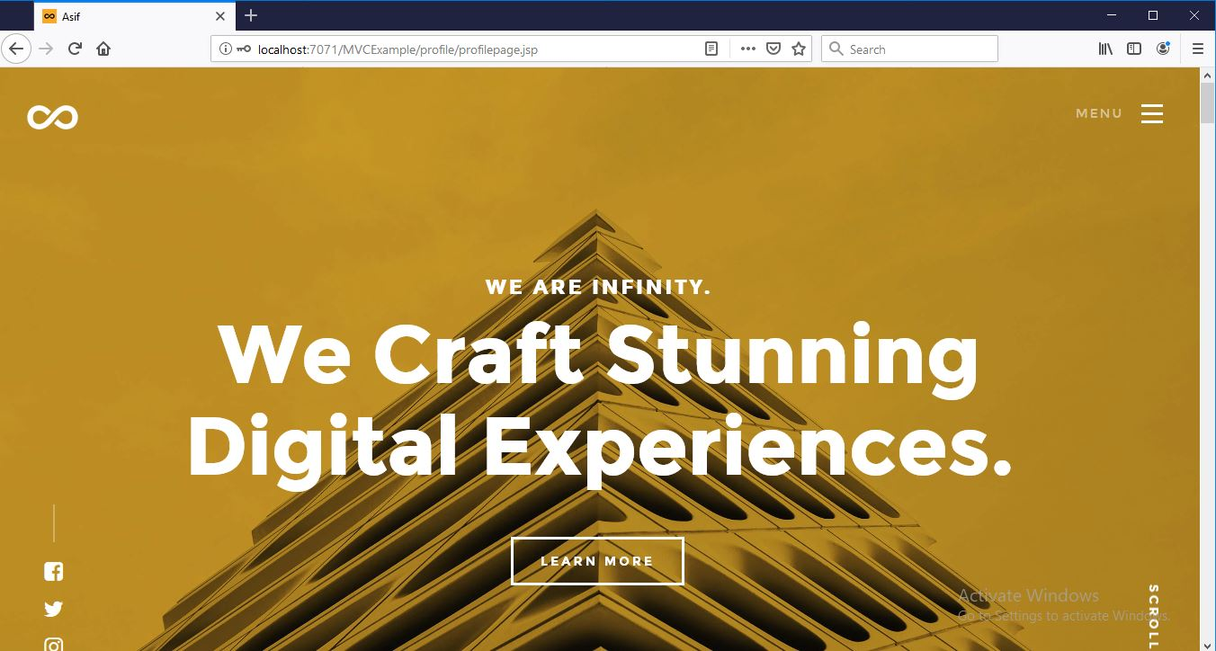

**Logout:**

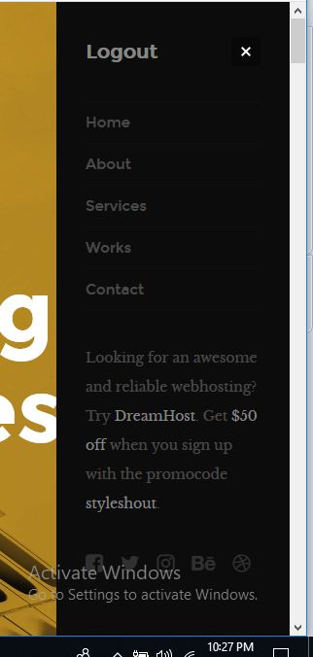

**Project Directory:**

